**Assignment: 1**

**Question. Why Python?**

**Answer:** Python is one of the most loved programming languages by developers, data scientists, software engineers, and even hackers because of its versatility, flexibility, and object-oriented features.   
Although it's a high-level language and but still we can do variety of complex tasks through It is easy to learn and has a clean syntax.

**Question. what are prev versions of python and differences?**

**Answer:**

**Python 3.8:** In rasa installation docs it says rasa works with python 3.8, but unfortunately this demo throws the following error while installing pip dependencies.

**Python 3.9:** Python 3.9 is the last version providing those Python 2 backward compatibility layers, to give more time to Python projects maintainers to organize the removal of the Python 2 support and add support for Python 3.9.

**Python 3.10:** Aliases to [Abstract Base Classes](https://docs.python.org/3/library/collections.abc.html#collections-abstract-base-classes) in the [collections](https://docs.python.org/3/library/collections.html#module-collections) module, like collections. Mapping alias to [collections.abc.Mapping](https://docs.python.org/3/library/collections.abc.html#collections.abc.Mapping), are kept for one last release for backward compatibility. They will be removed from Python 3.10.

**Question: Basic command of python.**

**Answer:** input, print, range, round, pip install, len, sort, loop, %run, %cd.

**Experiments**

1. Evaluate following and express the results:
2. 5 > 2.

Coding:

a = 5 > 2  
print("Value of a = ",a)

Output:

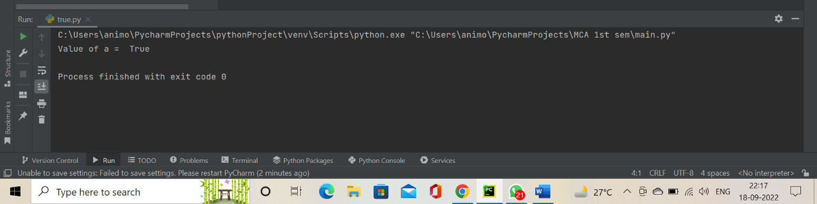

1. 5 == 2.

Coding:

a = 5==2  
print("Value of a = ",a)

Output:

1. 5 = 2.

Coding:

a = 5 = 2  
print("Value of a = ",a)

Output:

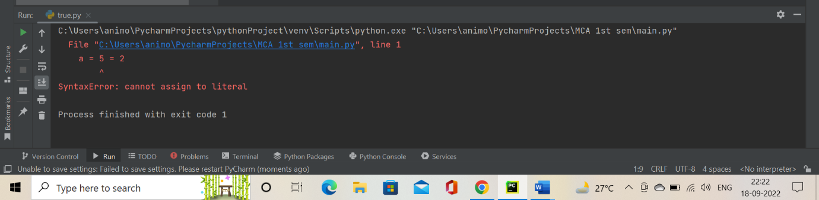

1. Determine whether the given number is even or odd.

Coding:

number=(int(input("Enter a number ")))  
  
if (number % 2) == 0:  
 print("{0} is a even number".format(number))  
else:  
 print("{0} is a odd number".format(number))

Output:

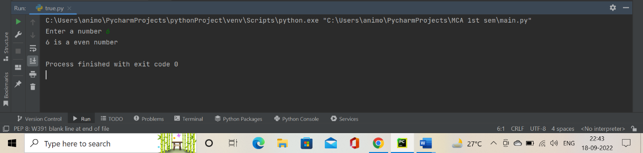

1. Marks of a student in five subjective are acquired. Determine average marks and grade. O - 91-100 A+ 81 -90 A 71 - 80 B+ 61-70 B 51 – 60 C+ 41 - 50 C 35 - 40 Fails otherwise.

Coding:

number1 = (int(input("Enter the Hindi marks = " )))  
number2 = (int(input("Enter the English marks = " )))  
number3 = (int(input("Enter the Maths marks = " )))  
number4 = (int(input("Enter the Science marks = " )))  
number5 = (int(input("Enter the Social science marks = " )))  
AVERAGE = (number1 + number2 + number3 + number4 + number5)/5;  
print("Your average marks is = ",AVERAGE)  
if AVERAGE<=100 and AVERAGE>=91:  
 print("Your grade is O")  
elif(AVERAGE<=90) and (AVERAGE>=81):  
 print("Your grade is A+")  
elif(AVERAGE<=80) and (AVERAGE>=71):  
 print("Your grade is A")  
elif(AVERAGE<=70) and (AVERAGE>=61):  
 print("Your grade is B+")  
elif(AVERAGE<=60) and (AVERAGE>=51):  
 print("Your grade is B")  
elif(AVERAGE<=50) and (AVERAGE>=41):  
 print("Your grade is C+")  
elif(AVERAGE<=40) and (AVERAGE>=35):  
 print("Your grade is C")  
else:  
 print("Sorry your are fail...")

Output:

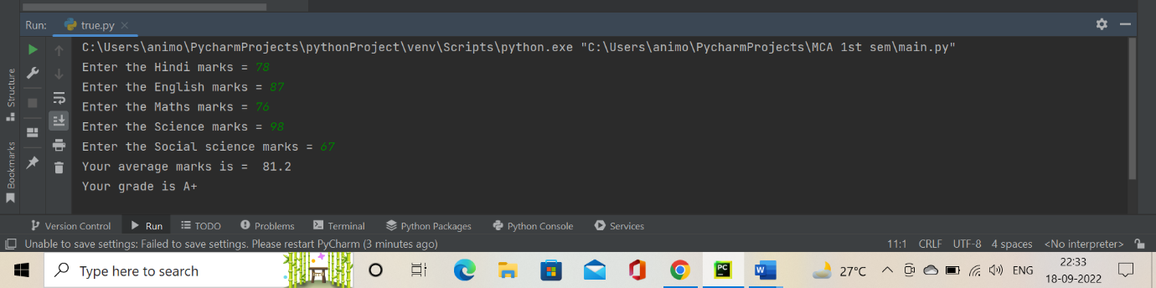

1. Evaluate 15 & 27 and verify your result.

Coding:

a=15&27  
print("Value of a = ",a)

Output:

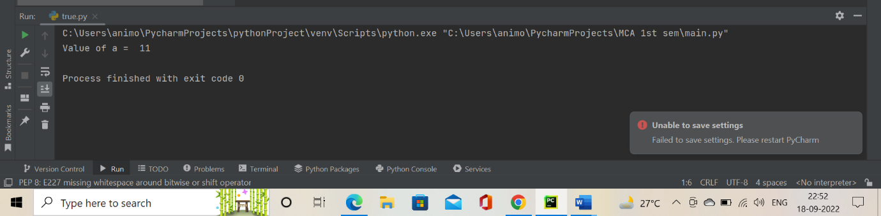

1. Evaluate 15 | 27 and verify your result.

Coding:

a=15|27  
print("Value of a = ",a)

Output:

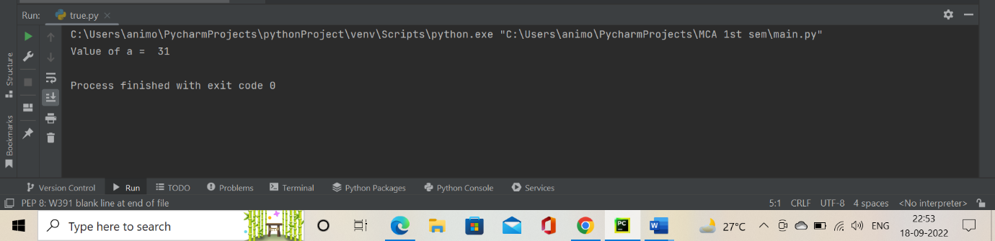

1. Evaluate 15 ^ 27 and verify your result.

Coding:

a=15^27  
print("Value of a = ",a)

Output:

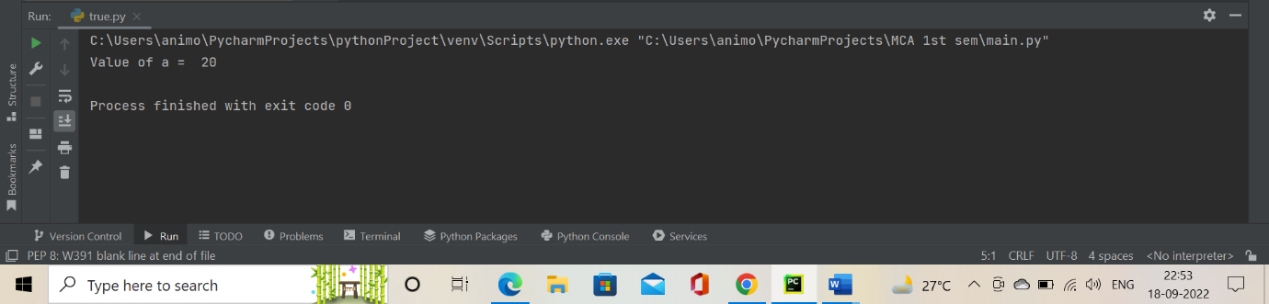

1. Multiply 3 by 4 using shift bitwise operator.

Coding:

a=3<<4  
print("Value of a = ",a)

Output:

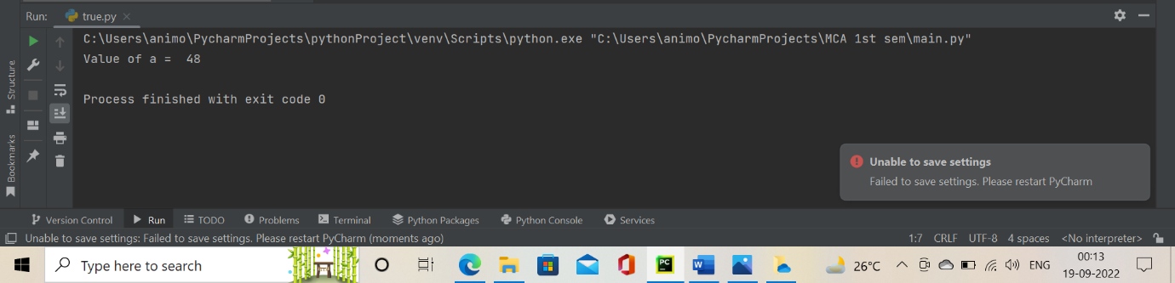

1. Divide 64 by 8 using shift bitwise operator.

Coding:

a=64>>8  
print("Value of a = ",a)

Output:

